Single Linked list

List: list is a sequence of data, and the linked list is a sequence of data linked with each other.

Single linked list is a sequence of elements in which every element has link to its next element in the sequence.

In any single linked list,

The individual element is called as "Node".

Every "Node" contains two fields,

data field,

and the next field.

The data field is used to store actual value of the node.

next field is used to store the address of next node in the sequence.



**Important Points to be Remembered**

In a single linked list, the address of the first node is always stored in a reference node known as "front"

(Some times it is also known as "head").

 Always next part (reference part) of the last node must be NULL.

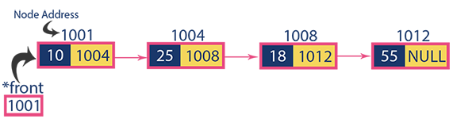

# Operations on Single Linked List

The following operations are performed on a Single Linked List

* **Insertion**
* **Deletion**
* **Display**